ARTH 345 Spring 2021
Northern European Art in the 17th Century
Student Name
Institution Affiliations
Date

Museum Exhibition
Introduction
Many of the modern Dutch paintings depict a natural lifestyle. Unfortunately, the original styles of Dutch Art flourished differently. Dutch existed as Northern and Southern Holland before the merge to form the modern-day Netherlands. The Flanders (Southern Holland) had a rich artistic tradition. Generally, Flemish Art depicts luxury and religion, whereas the Dutch Republic paintings show commerce, science, and secular Art. The eight-year war resulted in the migration of merchants, professionals, and skilled laborers to the northern provinces, bringing along their artistic expertise and art collections. The rich Art inspired the north to engage more in Art. It gave birth to the Golden Age of Dutch Art, a period of glorious artistic achievements. To understand more about the history of Dutch painting, the Museum exhibit at the National Art Gallery will present several traditional paintings with a variety of themes. During the colonial era, the Dutch were protestants. Therefore, a good percentage of the artwork during the Golden Age reflected the mythological beliefs of the Calvinism religion and Catholicism (religion of the Spanish who were the colonial masters at the time).
Theme: Mythology and Classical History
Mythology is an exciting concept in Art. It refers to the study and interpretation of various human cultures' sacred tales (Panofsky et al., 1933). Different cultures and religions have different forms of beliefs. For example, the 17th Century Dutch were protestants and believed in Calvinism, contrary to their colonial masters who were Christians and practiced Catholicism. Dutch painters portrayed both Calvinism and Catholicism through mythological drawings that depicted several differentiated ideologies. In a museum exhibit, several artistic works representing different mythologies and classical Art will be displayed styles from Flemish Art and Dutch Republic paintings. At the exhibition, I propose displaying the following three paintings from both the Flanders and Northerners.
Belshazzar’s Feast (1638) by Rembrandt van Rijn (Amsterdam)
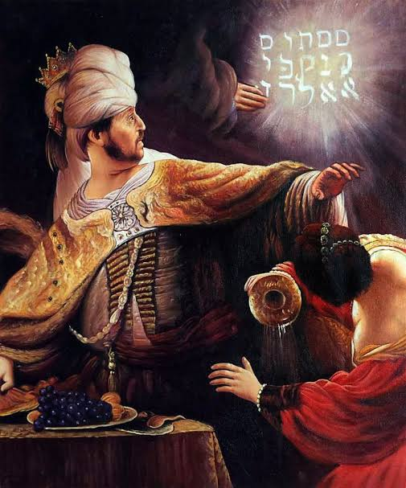
Rembrandt van Rijn was a prolific and innovative Dutch painter born in Leiden, the Dutch republic. As a former professor of Art, Rembrandt made several appealing artistic works of realism, including the famous Rembrandt’s self-portrait, the Night's Watch, the Anatomy Lesson of Dr. Tulip, the Storm on the Sea of Galilee, among many others, and Belshazzar's Feast among many others. Although many of Rembrandt's paintings were biblical, some were mythological, like the Belshazzar's Feast (Both Biblical and Mythological). In Belshazzar's Feast painting, Rembrandt narrates the story of Daniel from the Old Testament. The painting composes of the King of Babylon and his tiny crown (man in Gold cloak) and a woman holding an enormous turbine). In the middle of the painting, there is a clap of thunder that came as a warning. The hand of God wrote a Hebrew script, and within hours of notification, Belshazzar was dead. This is a religious image indicating the powers of a supreme God (Bomford et al. 2006). It paints a cautionary story of the fate of Belshazzar and a wicked king watched by the heavenly eyes. Although the Calvinists did not allow paintings in the church, the believers had artistic pictures in their houses, including religious paintings. I selected this image because it indicates the power of painting in the mid-17th Century by the Northern artists. Besides, the image shows the mythology of the power of God as believed by Christians.
Saint Sebastian (1623) by Gerrit van Honthorst (Utrecht)
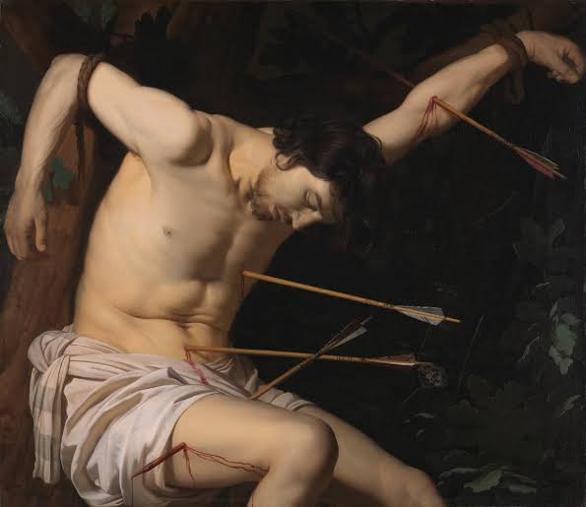
Gerrit van Honthorst is the second Golden Age Dutch painter. He was born in Utrecht, Dutch Republic (Present Netherlands). Having lived and attained part of his education in Italy, most of Gerrit’s paintings (commonly known as Caravaggio) depict more Italian cultural beliefs and religion. He, like Rembrandt, has many paintings known over the Netherland, Europe, and the world at large. They include the Matchmaker, Christ before High Priest, Musical group on a Balcony, the Adoration of the Christ Child, Saint Sebastian, and many more. According to Judson et al. (2013), the painting of Saint Sebastian depicts the story of the abusive relationship between the Catholics and the Calvinists (Protestants). It shows a man (Sebastian) rope tied on a tree with arrow shots. Sebastian was a Roman centurion. He is expected to be a protestant, but he was discovered to be a Christian, and therefore, sentenced to death by the Roman emperor Diocletian. He was tied to a tree and shot with arrows, and left to die. Unfortunately, the hands did not kill him, and hence, he was stoned to death. The image was highly adopted by both the Catholics and the Calvinists. The Catholics adopted it as St. Sebastian, a believer who valued Christianity. The Calvinists, on the other hand, adopted it as a way to show defectors what would befall them if they abandon their religion. I chose this painting for the exhibit because it shows the ancient Dutch beliefs and the conflict between the Protestants and the Catholics at the time.
Mars and Venus Discovered by the Gods (1604) by Joachim Wtewael (Utrecht)
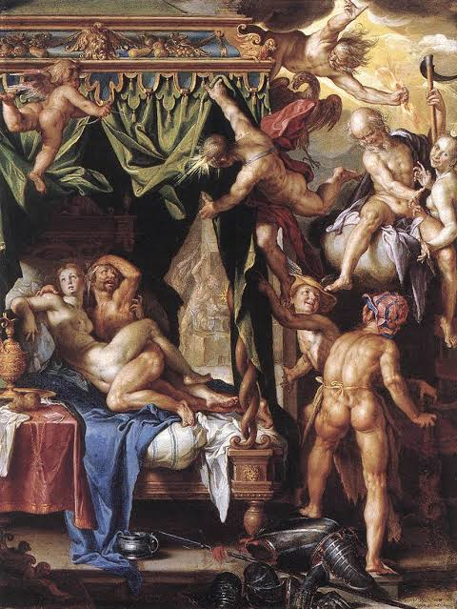
The third artist is Joachim Anthoniszon Wtewael. Like Rembrandt and Gerrit, he was also from the Dutch Republic in the province of Utrecht. He is famous for paintings such as Mars and Venus Discovered, the Golden Age, Perseus and Andromeda, Moses Striking the Rock, the raising of Lazarus, and the Judgement of Paris. The majority of Wtewael’s paintings are a classical history of Biblical events. As stated by Lowentha et al. (1995), the painting of Mars and Venus Discovered by the Gods is an Ovidian that depicts the gods witnessing in laughter as Mars and Venus as they are stripped naked by Vulcan (Venus's husband-Front right standing on Mars’s armor) with his kiln glimpsed behind. Also in the scene are Apollo and Cupid hovering in the air as they lift the bed curtains to offer a view to the gods and enable us (the viewers) a peek of the adultery committed by Mars Venus. This painting depicts the mythology of human beliefs in the existence of gods. I chose this painting because it gives a pick of the gods, goddesses, and biblical figures engaging in adulterous acts and lousy behavior as God went wild. The painting shows the ability and the skills of the Dutch as master painters. As a Calvinist, Wtewael embraced Calvinist religion, which formed the pillar of the Dutch community.
Conclusion
The three paintings by Rembrandt, Gerrit, and Wtewael depict mythological aspects. Although the paintings are different and portray different artistic elements, they are all based on traditional tales, religious beliefs, and legends. All mythological figures such as Apollo, Cupid, and Dionysus depict a religious belief. Therefore, the paintings listing and display in the Museum Exhibit go hand in hand with Mythology's theme. By viewing these three paintings at the show, people will understand that the Golden Age of Art gave Dutch its artistic country name. Also, people will understand the reasons behind the religious differences between the protestants and Catholics in the country. modern-day Art is interpreted
References
Bomford, David, et al. Art in the making: Rembrandt. Yale University Press, 2006.
Judson, J. Richard J. Gerrit van Honthorst: a discussion of his position in Dutch Art. Springer, 2013.
Lowenthal, Anne W. Joachim Wtewael: Mars and Venus Surprised by Vulcan. Getty Publications, 1995.
Panofsky, Erwin, and Fritz Saxl. "Classical mythology in mediaeval art." Metropolitan Museum Studies 4.2 (1933): 228-280.

